GDSP WEEKDAY BATCH
Kunal babar

Write the following queries based on the above schema:

1. Create the tables mentioned in the above schema with given constraints.
create database food; use food;
--------------------------------------------- #creating sandwiches table# create table sandwiches(
sid varchar (10) primary key,name_ varchar (20), filling varchar (20), bread varchar (20),price bigint (10));
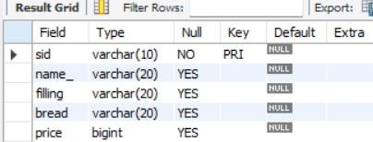
---------------------------------------------------
#creating location table# create table location(
loc_id varchar (10) primary key, sid varchar (10), address varchar (20), phone bigint (10), foreign key(sid) references sandwiches(sid));
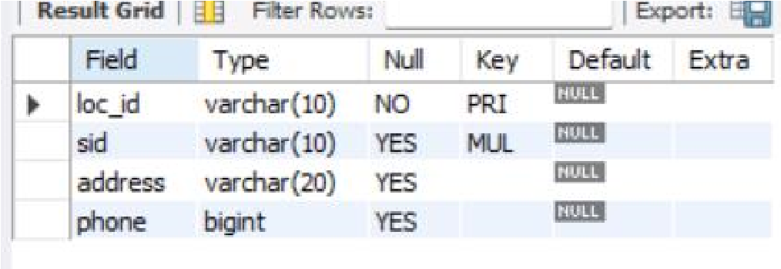
2. Insert the given records in the tables.

#adding values in sandwiches#
insert into sandwiches values('s1','san-chicken','chicken','white',50);
insert into sandwiches values('s2','san-chicken','chicken','brown',55); insert into sandwiches values('s3','san-veggie','mixed veg','brown',50); insert into sandwiches values('s4','san-veggie','mixed veg','multi grain',55); insert into sandwiches values('s5','aloo tikki','potato','rye',25); insert into sandwiches values('s6','mexican veg','mayonese','white',45); insert into sandwiches values('s7','mixed cheese','cheese,veg','white',60);
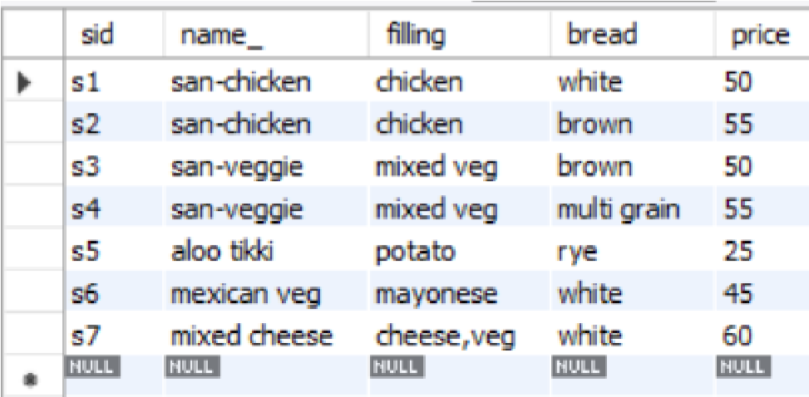

#adding values in location# insert into location values('l1','s1','Mumbai,Goregaon',9899674560); insert into location values('l2','s4','Mumbai,Kandivali',0223456789); insert into location values('l3','s5','Banglore',0402567834); insert into location values('l4','s7','Chennai,Madurai',9823450032); insert into location values('l5','s6','Kolkata,Parkstreet',03324560022); insert into location values('l6','s2','Kolkata,Esplanade',03325678903); insert into location values('l7','s3','Kerala,Kochin',9920456033); insert into location values('l8','s4','Delhi,Kannaught Place',9923458888);
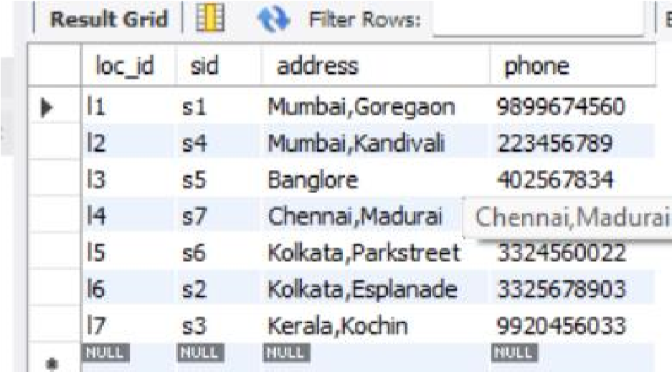

3. Display the records from the sandwich table where the price is more than 50.

#Display the records from the sandwich table where the price is more than 50.# select * from sandwiches where price >50;
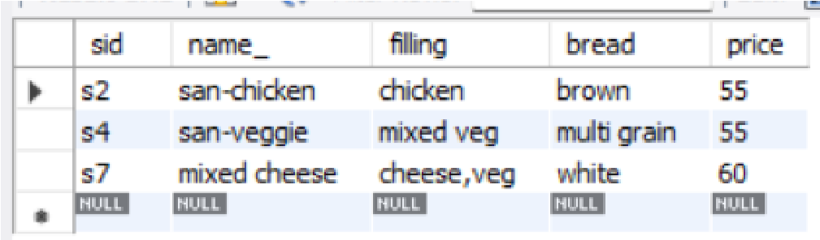

4. Display the names of sandwiches where price lies between 25 and 50.

#Display the names of sandwiches where price lies between 25 and 50# select * from sandwiches where price>=25 and price<=50;
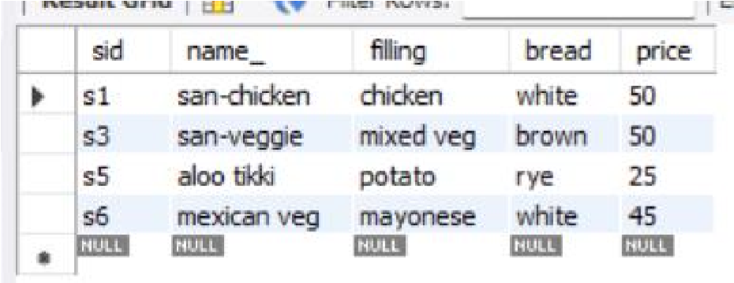

5. Display sandwiches which are available in Mumbai.

#Display sandwiches which are available in Mumbai# select name_,address from sandwiches,location where sandwiches.sid=location.sid and address like '%Mumbai%';
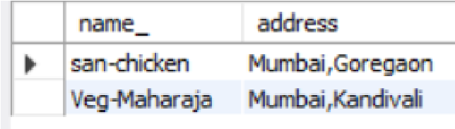

6. Display the names of sandwiches where filling contains veg.

#Display the names of sandwiches where filling contains veg# select name_,filling from sandwiches where filling not like '%chicken%';
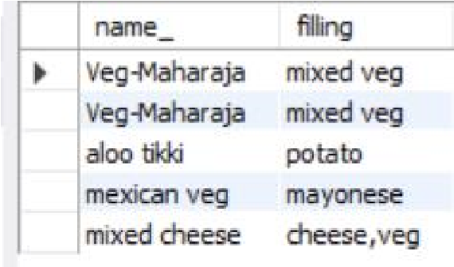

7. Display the prices of the sandwiches made of brown bread.

#Display the prices of the sandwiches made of brown bread# select price,bread from sandwiches where bread like '%brown%';

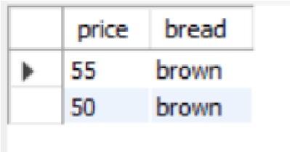

8. Display the details of the sandwiches after replacing San-veggie with Veg-Maharaja.

#Display the details of the sandwiches after replacing San-veggie with Veg-Maharaja# update sandwiches
set name_='Veg-Maharaja' where sid='s3'; update sandwiches
set name_='Veg-Maharaja' where sid='s4'; select * from sandwiches where name_='Veg-Maharaja';
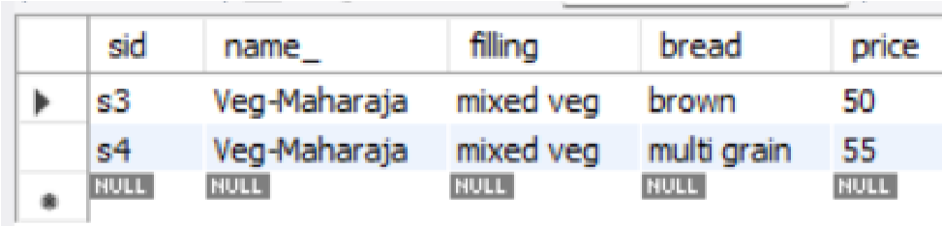

9. Sort the records of the sandwich table on the column bread.

#Sort the records of the sandwich table on the column bread# select * from sandwiches order by bread;
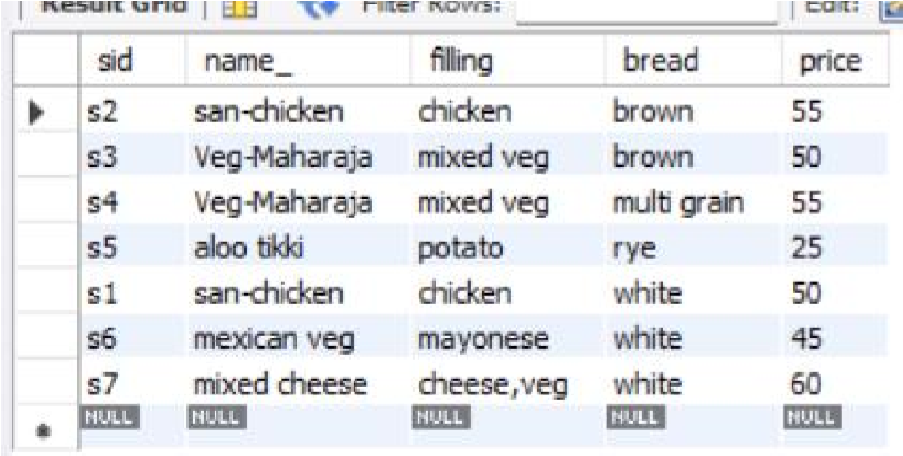

10. Display the details of the sandwiches which are not made in white and Multi grain bread.

#Display the details of the sandwiches which are not made in white and Multi grain bread# select * from sandwiches
where bread!='white' and bread!='multi grain';
